Information on tourist spots around Ojiya

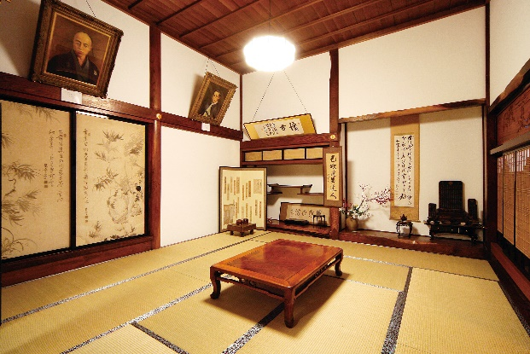
Jigen-temple

It was built in 650 and enshrines a statue of Shō-kan -Zennon -bosatsu, a goddess of mercy.
It is the place “Ojiya negotiation”(peace negotiation) was held in 1868. During the Boshin War, the battle of Hokuetsu started after the negotiation that Nagaoka faudal clan petitioned the new government troop for armed neutrality broke off.
Here is an interesting history about Jigen-temple. When the statue was brought to Edo to be exhibited in 1691, the schedule was extended to 60 days because it became exceedingly popular than expected. Even Shogun tsunayoshi TOKUGAWA visited to worship and he dedicated his sensu(a folding fan). The sensu still preserved at Jizen-temple as a historical treasure.

Related Website URL: http://www.myoukouji.com/
Address: 114 kawai, Ojiya, Niigata

